Project Development Phase
Model Performance Test
Date | 21 February 2026
Team ID | LTVIP2026TMIDS65711
Project Name | Online Payments Fraud Detection using Machine Learning
Maximum Marks
Model Performance Testing:
The following table summarizes the performance evaluation of the trained XGBoost fraud detection model.
S.No. | Parameter | Values | Screenshot
1 | Model Summary | XGBoost Classifier trained on Kaggle dataset using transaction behavior features. | 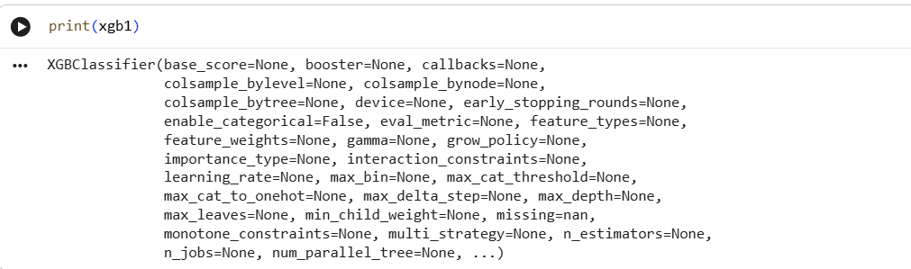
2 | Accuracy | Training Accuracy: 99.99%  Validation Accuracy: 99.98% | 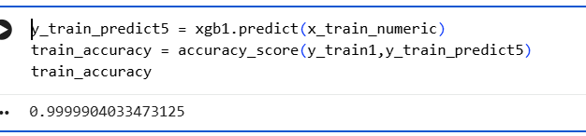
3 | Fine Tuning Result | Validation Accuracy after tuning: 99.98% | 